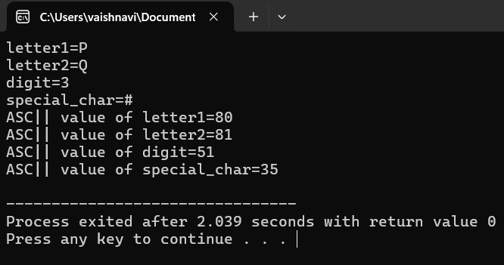
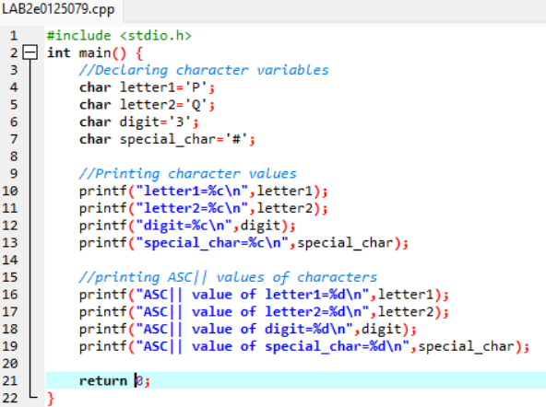
Write a C PROGRAM TO DEMONSTRATE CHARACTER DATATYPE

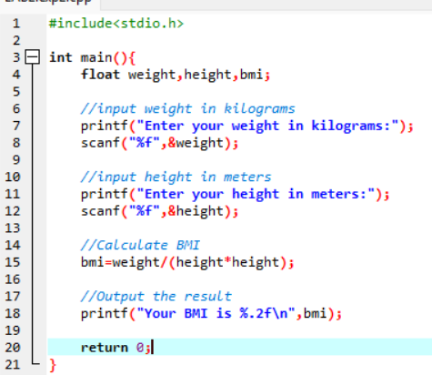
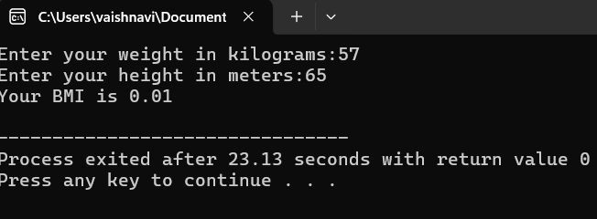
Write a C program to demonstrate float datatype for BMI calculation

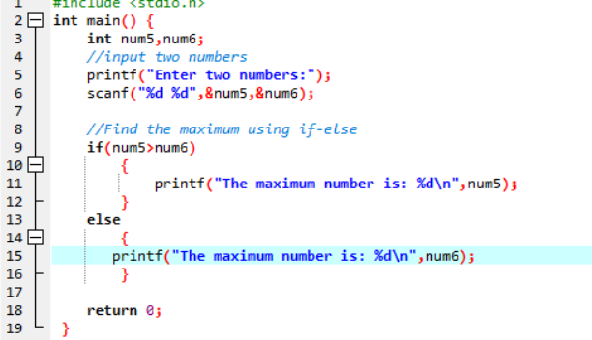
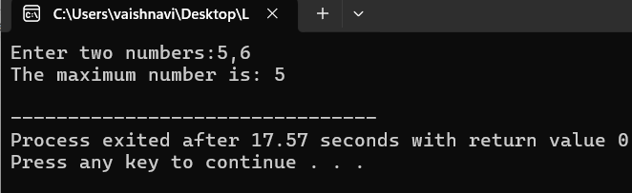
Write a C program to find the maximum of two numbers

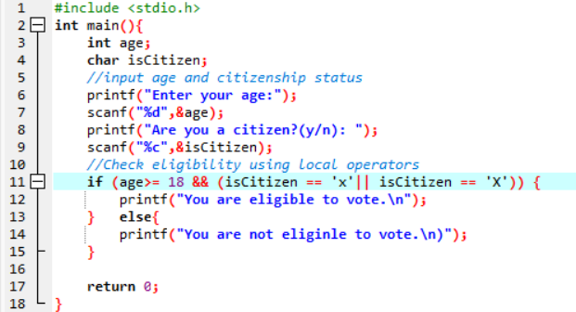
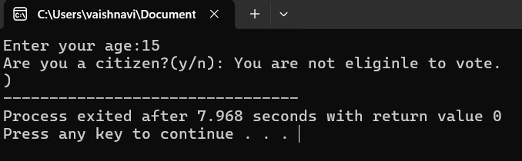
WRITE A C PROGRAM FOR VOTING ELIGIBILITY CHECK USING LOGICAL OPERATORS

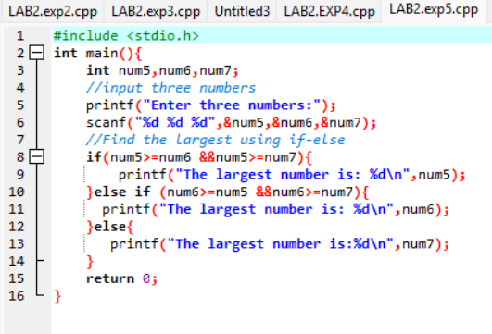
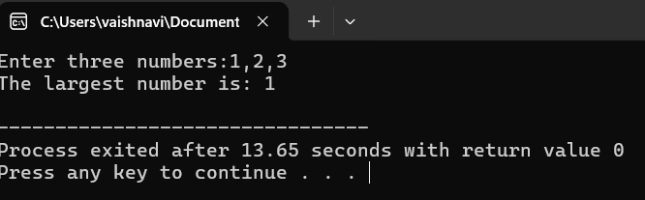
Write a C program to find the largest of three numbers

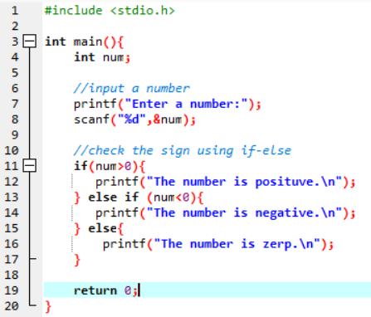
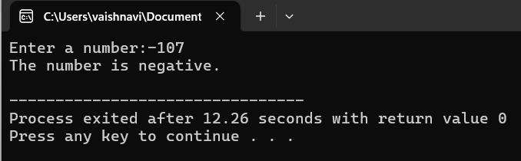
Write a C program that takes an integer as input and checks if it’s a positive or negative or zero usinf if-else statements

Create a C program that calculates the grade of a student based on their percentage score.Use if and else-if statements to assign grades (A,B,C,D orF)according to the following criteria:
A:90% or above
B:80-89%
C:70-79%
D:60-69%
F:below 60%

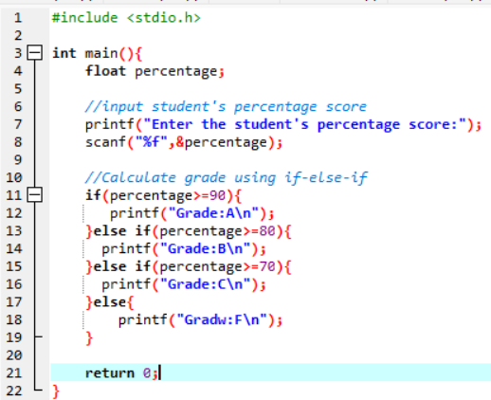
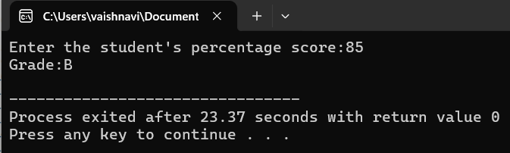

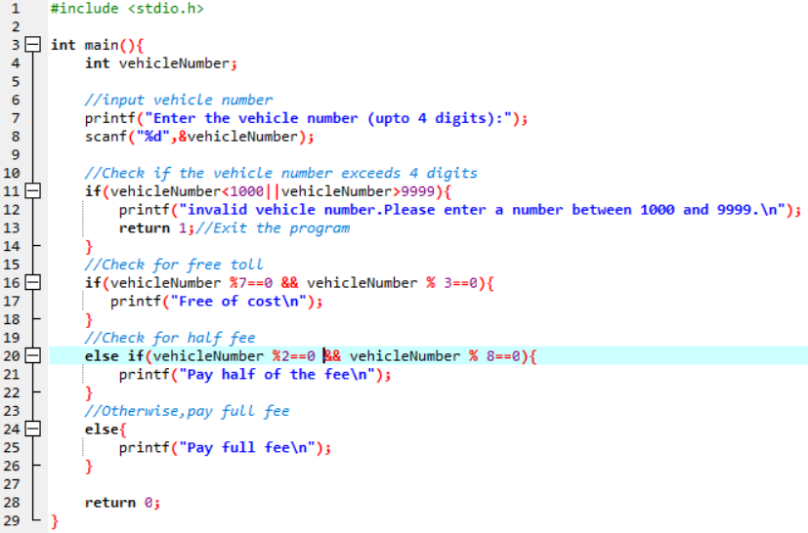
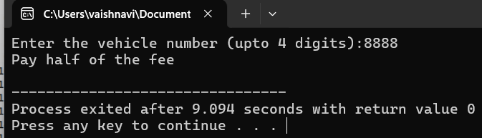
National highway announces a scheme for the four wheeler in tollgate for 50th year celebration.If the vehicle number is divisible by both 7 and 3 that will move on for free of cost.If the vehicle number is divisible by 2 and 8 then they should pay half of the fee.Otherwise you have to pay.make sure the vehicle number doesn’t exceed 4 numbers

